Military Institute of Science and Technology
Department of Computer Science and Engineering
Course Title: Data and Tele- Communication Sessional
Course Code: CSE-306, Cr. Hr: 1.50
Level-3, Term-2

Experiment No: 04

Name of the Experiment: FM Demodulation

1. Objectives:

- To understand the operation theory of phase locked loop.
- To understand the basic characteristics of MC4046 phase locked loop.
- To understand the basic characteristics of LM565 phase locked loop.
- To design and implement the FM demodulator by using MC4046.
- To design and implement the FM demodulator by using LM565.
- Theory:

Frequency demodulator is also called frequency discriminator, which can convert the variation of frequency to the variation of linear voltage. Normally we use FM to AM conversion circuit, balanced discriminator circuit, phase shift discriminator circuit and PLL synthesizer for the FM demodulator. In this chapter, we will introduce the phase locked loop frequency demodulator FM to AM conversion discriminator.

The Operation Theory Of Phase Locked Loop

Phase locked loop or PLL is a feedback circuit. In the feedback loop, the feedback signal will lock the output signal frequency and phase with the same frequency and phase of the input signal. So, for wireless communication if the frequency of the carrier signal deviation during transmission, then the PLL in the receiver will operate andlock the carrier signal. In this experiment, there are two types of using PLL, and the first is demodulator, which is used fior demodulation by following the variation of phase and frequency. The second is the carrier frequency tracking which is used to track the changes of the frequency of the carrier signal and synchronize the oscillation.

Normally, phase locked loop can be divided into 3 sections, there are
- Phase detector (PD)
- Low-pass filter (LPF)
- Voltage controlled oscillator (VCO)
From figure 8-1, the function of phase detector is to receive input signal and VCO signal, then the two signals are compared by phase detector and provided an output signal, which is a pulse signal. After that this signal is then sent to a low pass filter to remove the unwanted signal and left the DC voltage.
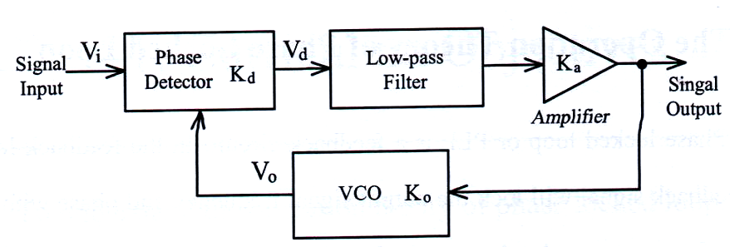

Fig 8-1 Blocked diagram of Phase locked loop.

This DC voltage can be used to con troll the output signal frequency of VCO. Fig 8-1 the Blocked diagram of Phase locked loop, Where

Kd = The gain of phase detector (Volts/Radian)
Ka = The gain of amplifier (Volts/Volts)
Ko = The gain of VCO (kHz/Volts)
K_{L} = K_{d} K_{a} K₀ = The gain of closed loop (kHz/Radian)

We use a simple circuit to explain the basic concept of phase detector. From figure 8-2 (a) shows the phase difference between two input signal is the smallest, So the output signal pulse width is the narrowest. Then From figure 8-2 (b) shows the phase difference between two input signal is larger than figure 8-2 (a), So the O/P signal pulse width is wider than figure 8-2 (a). Figure 8-2 (c) shows the phase difference between two input signal is the largest and therefore the output signal pulse width is the widest. If this three output signals pass through the low pass filter to remove the AC signal, then the magnitude of DC voltage in figure 8-2 is as follow: 1 Figure 8-2 (c) has the highest DC voltage , 2. figure 8-2 (b) is the second higher, and 3. figure 8-2 (a) is the lowest. The relation of DC voltage and the phase difference of A, B input signals is shown in fig 8-2 (d).
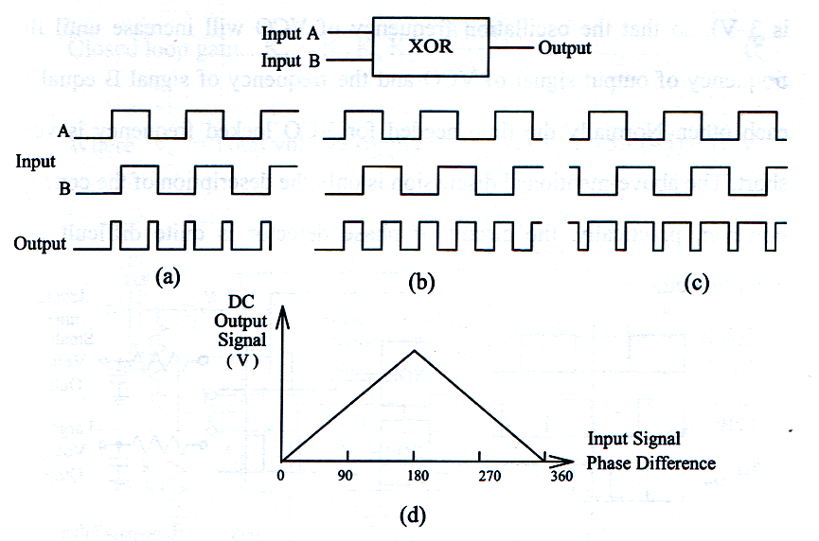

Fig 8-2 Theory of phase detector

From fig 8-3, assume that the free running frequency of a VCO is set to 1 kHz (assume the bias voltage is 2 V). If inputting a signal A is below 1 kHz and a signal B is higher than 1 kHz. From figure 8-3, we found that, when input signal A frequency lower than the free running frequency of VCO, then the output of low pass filter will receive a lower voltage level (assume is 1 Volt), this lower voltage will adjust the oscillation frequency of VCO, so that the oscillation frequency will decrease until the frequency of output signal of VCO and the frequency of signal A equal to each other. When input signal B frequency is higher than the basic frequency of VCO, the output terminal of low pass filter will receive a higher voltage (assume is 3 V), so that the oscillation frequency of VCO will increase until the frequency of output signal of VCO and the frequency of signal B equal to each other. Normally the time needed for VCO locked frequency is very short. The above mentioned discussion is only the description of the concept, however, practically; the circuit of phase detector is quit difficult and complicated.

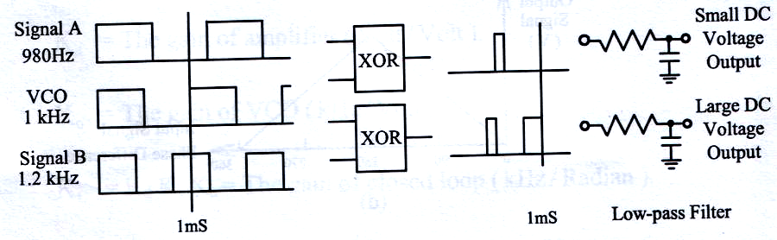

Fig 8-3 Theory of locked frequency

The Basic Characteristics of PLL LM565

(i) Free running frequency

Figure 8-4 is a LM 565 Phase locked loop circuit diagram, from figure 8-4, when input terminal does not input any signal, the output signal frequency of VCO is called free-running frequency. Where C2 is timing capacitor, VR1 is timing variable resistor, the free-running frequency (fo) of LM565 is decided by C2 and VR1.
Free-running frequency : 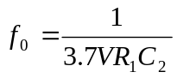 ............................................. 8-1
Closed loop gain : 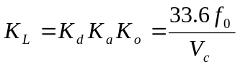 ................................................... 8-2
Where V_{c} = Total voltage supply = 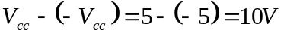
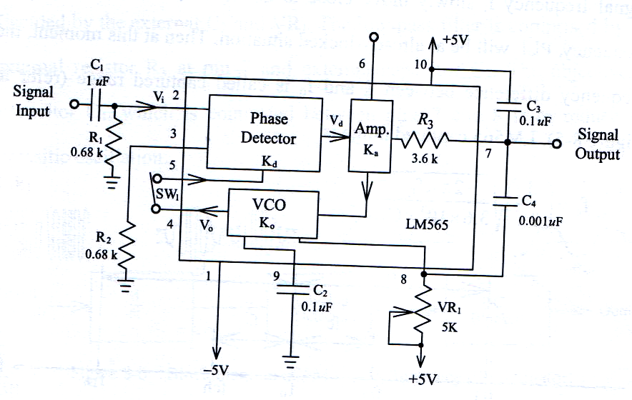

Figure 8-4 LM565 phase locked loop.

(2) Locked Range
When phase locked loop circuit is at al ready –locked situation, assume the input signal frequency 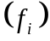slowly move away from fo, when reaches at a certain frequency, the PLL will leave the locked situation. At this moment, the maximum frequency difference for frequency and 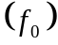 is called locked range (refer to fig 8-5). The locked range of LM565 is

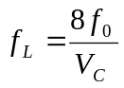 ....................................................... 8-3
(3) Captured range
At the beginning, LPP is not locked situation, and then let the input signal frequency fi slowly move close to fo, when fi, reaches at a certain frequency, PLL will be at already-locked situation. Then at this moment, the frequency difference between fi and fo is called Captured range (refer to fig 8-5). LM 565 Captured range is

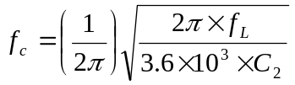 ................................................... (8-4)

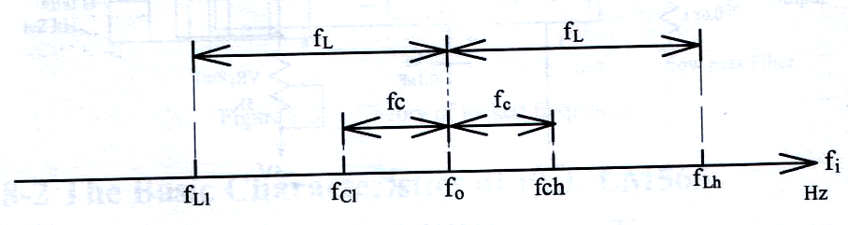

Figure 8-5 Lock range and capture range diagram

Implementation of FM demodulator by Using LM 565PLL

Figure 8-4 is the circuit diagram of LM 565 Phase locked loop., we can use this circuit as a FM demodulator. When the input signal frequency increases, then the output signal voltage decreases. However, when the input signal frequency decreases, the output signal voltage will increase, therefore, we can utilize the relationship between the voltage of PLL and frequency to design the FM demodulator.
LM565 phase detector and VCO are designed in the IC package, this VCO and LM566 are the same. The free running frequency 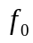 of VCO is decided by the external C₂ and VR₁. The low-pass filter is comprised by the internal resistor R₃ at pin 7 and external capacitor C₃. The objective of capacitor C₄, which is connected between pins 7 and 8 is to reduce the paracitic oscillation.

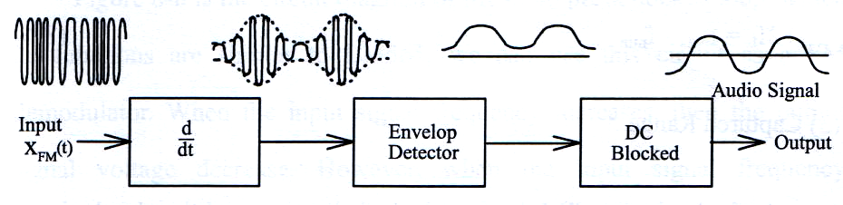

Figure 8-6 block diagram of FM to AM frequency discriminator.

Basic characteristics of PLL MC 4046

1. Free running frequency

Figure 8-6 is a MC4046 phase locked loop circuit diagram. From figure 8-6, when input terminal does not input any signal, the output signal frequency of VCO is called free running frequency. Where C₂ is timing capacitor, VR₁ is timing variable resistor, the free-running frequency 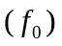 of MC4046 is decided by C₂ and VR₁.
Free running frequency : 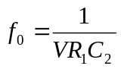 ............................................ 8-5
(2) Locked Range

When phase- locked loop circuit is at already –locked situation, assume the input signal frequency (f_{i}) slowly move away from f_{o}, when f_{i} reaches at a certain frequency, the PLL will leave the locked situation. At this moment, the maximum frequency deference for frequency f_{i} and f_{o} is called locked- range (refer to figure 8-5). The locked-range of MC4046 is

2f_{L} = f_{max} – fmin............................................................................(8-6)

_{(3) Captured Range}

At the beginning, PLL is at not locked situation, and then let the input signal frequency f_{i} slowly move close to f_{o}, when f_{i} reaches at a certain frequency, PLL will be at already-locked situation. Then at this moment, the frequency difference between f_{i} and f_{o} is called captured range (refer to Figure 8-5). The captured range of MC4046 is

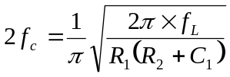..................................(8-7)
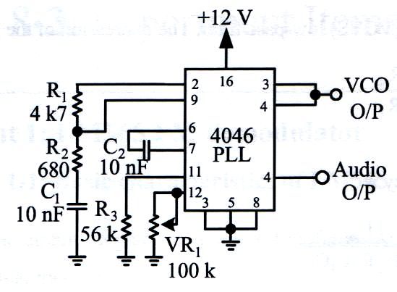

Figure 8-6 Circuit diagram of MC4046 PLL.

Implementation of FM demodulator by Using MC 4046 PLL

Figure 8-6 is the circuit diagram of MC4046 phase-locked loop, which its functions are similar to LM565, we can use this circuit as a FM demodulator. When the input signal frequency increases, then the output signal voltage decrease. However, when the input signal frequency decreases, the output signal voltage will increase, therefore, we can utilize the relationship between the voltage of PLL and frequency to design the FM demodulator.
As a result of the demodulated audio signal consists of noise signal, therefore, we utilize the low- pass filter in figure 8-7 to remove all the unwanted signal. Capacitors C₁, C₂, resistors R₁, R_{2,} R₃ , R₄ and A741 comprise an active low-pass filter . This structure is a voltage controlled voltage source (VCVS) low- pass filter. The expression of the gain is

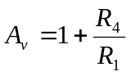............................... (8-8)

Cutoff frequency is

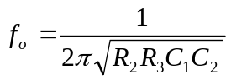 ................................................ (8-9)

If R₂ = R₃ = R and C₁ = C₂ = C, then

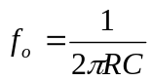 .................................................................... (8-10)

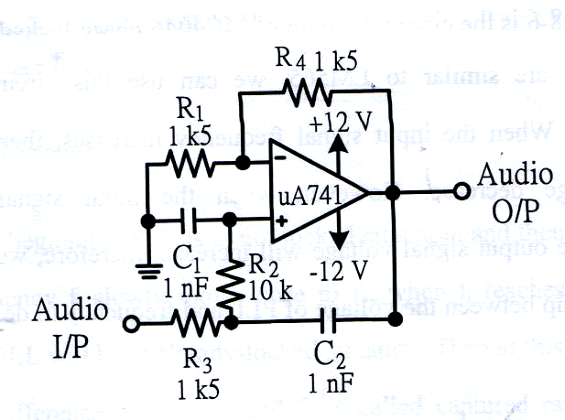

Figure Circuit diagram of second order active low pass filter.

3. Equipments Needed

ETEK module LM565 demodulator
ETEK module MC4046 demodulator
SIgnal source (Function generator)
Oscilloscope
Spectrum analyzer

4. Procedure understanding basic characteristics of LM565

- Refer to the circuit diagram in figure 8-4 or figure ACS8-1 on ETEK ACS-3000-04 module.
- Let J2 be short circuit and J3 be open circuit, i.e. C₂ = 100 nF. Let J1 be open circuit, i.e. SW₁ be open circuit.
- Adjust the variable resistor VR₁, then measure the maximum (f_{0h}) and minimum (f_{ol}) free running frequencies (refer to figure 8-5) at the VCO output port (VCO O/P). Then record the measured results in table 8-1.
- Adjust the variable resistor VR₁ so that the free-running frequency of VCO O/P (f_{o}) is 2 KHz.
- Let J1 short circuit, and at the input port, input 0.25V amplitude and 2 KHz square wave frequency.
- By using oscilloscope, observe on the demodulated output port (Audio O/P). Slightly increase the input signal frequency unit the output signal frequency of Audio O/P is unable to lock input signal. Then record the signal frequency f_{LH} at this moment in table 8-1.
- Readjust the input signal frequency to the free running frequency (f_{o}) of PLL. Then decrease the input signal frequency until the output signal frequency of Audio O/P is unable to lock input signal. Then record the input signal frequency f_{L1} at this moment in table 8-1.
- By using equation f_{L} = (f_{Lh} – f_{L1})/2, then calculate the locked range.
- Increase the input signal frequency so that the output signal frequency of Audio O/P is unable to lock the in put signal. Then slightly decrease the input signal frequency until the audio O/P locks the input signal. Then observe on the input signal frequency f_{Ch} and record the measured results in table 8-1.
- Decrease the input signal frequency so that the output signal frequency of Audio O/P is unable to lock the input signal. Then slightly increase the input signal frequency until the Audio O/P locks the input signal. Then observe on the input signal frequency f_{C1} and record the measured results in table 8-1.
- By using equation f_{C} = (f_{Ch} – f_{C1})/2, then calculate the captured range.
- Let J1 be open circuit, J3 be short circuit and J2 be open circuit, which means that C₂ changes to C₅, i.e. 100nF changes to 10 nF, then repeat step 3.
- Adjust the variable resistor VR₁, so that the free running frequency (f_{o}) of the VCO O/P is 20 KHz. Let J1 be short circuit and at the input terminal, input 0.25 V amplitude and 20 Khz frequency square wave frequency, then repeat step 6 to step 11.

Table 8-1 Measured results of the basic characteristics of LM565 PLL.

C₂ | f_{o} | Free running frequency range |  | Locked range f_{L} |  |  | Captured range f_{C}
C₂ | f_{o} | f_{oh} | fol | f_{Lh} | f_{L1} |  | f_{Ch} | f_{C1}
100  nF | 2  KHz | Hz | Hz | Hz | Hz |  | Hz | Hz
 |  | Hz | Hz | f_{L} = _________Hz |  |  | f_{L} =_______-Hz
10  nF | 20  KHz | Hz | Hz | Hz |  | Hz | Hz |  | Hz
 |  |  |  | f_{L} = _________Hz |  |  | f_{L} =_______-Hz

Procedure understanding voltage and frequency conversion of LM565
a. Refer to the circuit diagram in figure 8-4 or figure ACS8-1 on ETEK ACS-3000-04 module.
b. Let J2 be short circuit and J3 be open circuit, i.e. C₂ = 100 nF. Let J1 be open circuit and adjust the variable resistor VR₁ so that the free running frequency (f_{o}) of VCO O/P is 2 KHz.
c. Let J1 be open circuit, i. e. SW₁ be open circuit.
d. At the demodulated FM input port (FM I/P), input 0.25 amplitude and 2 KHz square wave frequency. Then measure the voltage of Audio O/P and record the measured results in table 8-2.
e. Change the input signal frequencies to 0.5 KHz, 1KHz, 1.5KHz, 2KHz, 2.5KHz, 3KHz, 3.5 KHz. Then measure the voltage of Audio O/P and record the measured results in table 8-2.
f. Sketch the characteristics diagram with voltage versus frequency in figure 8-8.
g. Let J3 be short circuit and J2 be open circuit, which means that C₂ changes to C₅, i.e. 100 nF changes to 10nF.
h. Let J1 be open circuit and adjust the variable resistor VR₁, so that the free running frequency (f_{o}) of the VCO O/P is 20 KHz.
i. Let J1 be open circuit, i .e. SW₁ be open circuit.
j. At the FM I/P, input 0.25 V amplitude and 20 KHz square wave frequency. Then measure the voltage of Audio O/P and record the measured results in table 8-3.
k. Change the input signal frequencies to 16.5 KHz, 17.5KHz, 18.5KHz, 20.5KHz, 21.5KHz, 22.5KHz, 23.5 KHz. Then measure the voltage of Audio O/P and record the measured results in table 8-3
l. Sketch the characteristics diagram with voltage versus frequency in figure 8-9.
Table 8-2 Measured results of the voltage and frequency conversion characteristics of LM565 PLL. (V_{m} = 0.25V, f_{o} = 2KHz, C₂ = 100 nF)

Input signal frequencies  (KHz) | 0.5 | 1.0 | 1.5 | 2.0 | 2.5 | 3.0 | 3.5
Output voltage
(V)

Figure 8-8 Characteristics curve of voltage versus frequency.
Table 8-3 Measured results of the voltage and frequency conversion characteristics of LM565 PLL. (V_{m} = 0.25V, f_{o} = 20KHz, C₂ = 10 nF)

Input signal frequencies  (KHz) | 16.5 | 17.5 | 18.5 | 20 | 21.5 | 22.5 | 23.5
Output voltage
(V)

Figure 8-9 Characteristics curve of voltage versus frequency.

6. Procedure for LM 565 FM demodulator

1. Refer to the circuit diagram in figure 7-6 or figure ACS7-2 on ETEK ACS 3000-04 module to produce the demodulated FM signal as the signal source. Let J1 be short circuit, i.e. the circuit is the FM modulator. J3 be short circuit and J2 be open circuit, i.e. the selected capacitor is C4 = 10 nF. Adjust variable resister VR1 so that the frequency at the modulated FM output port (FM O/P) is 20 kHz square wave.

b. Refer to the circuit diagram in figure 8-4 or figure ACS8-1 on ETEK ASC-300-04 module. Let J3 be short circuit, J1 and J2 be open circuit, i.e. C₅ = 10 F. Adjust the variable resistor VR_{1,} so that the free –running frequency (f_{o}) of the VCO O/P is 20 kHz.
c. Connect the output port (FM O/P) of the VCO LM566 to the input port (FM I/P) of the PLL LM565.
d. At the audio input port (Audio I/P) of the VCO LM566, input 250 mv amplitude and 1 kHz sine wave frequency. By using oscilloscope, observe on the output signal waveforms of the demodulated FM signal (Audio O/P) at PLL LM565. Then record teh measured results in table 8-4.
e. According to the input signals in table 8-4, repeat step 4 and record the measured results in table 8-4.

f. According to the input signals in table 8-5, repeat step 4 and record the measured results in table 8-5

Table 8-4 Measured results of input and output signal waveforms of PLL frequency demodulator. (V_{m} = 250 mV, f₀ = 20 KHz)

Audio signal frequencies | FM I/P | Audio O/P
1 KHz
2 KHz
3 KHz

Table 8-5 Measured results of input and output signal waveforms of PLL frequency demodulator. (V_{m} = 500 mV, f₀ = 20 KHz)

Audio signal frequencies | FM I/P | Audio O/P
1 KHz
2 KHz
3 KHz

7. Procedure for MC 4046 FM Demodulator

Refer to the circuit diagram in figure 7-5 or figure ACS7-1 on ETEK ACS 3000-04 module to produce the demodulated FM signal as the signal source. Adjust variable resister VR1 so that the frequency at the modulated FM output port (FM O/P) is 20 kHz square wave.
Refer to the circuit diagram in figure 8-6 or figure ACS8-2 on ETEK ACS 3000-04 module. Adjust the free running frequency (fo) of the VCO output port (TP1) be 20 kHz.
Connect the output port (FM O/P) of the VCO MC 4046 to the input port (FM I/P) of the PLL MC 4046.
At the audio input port (Audio I/P) of the VCO MC4046, input 250 mV amplitude and 1 kHz sine wave frequency. By using oscilloscope, observe on the output signal waveforms of the demodulated FM signal (Audio O/P) at PLL MC4046. Then record the measured results in table 8-6
According to the input signal in table 8-6, repeat step 4 and record the measured results in table 8-6.
According to the input signal in table 8-7, repeat step 4 and record the measured results in table 8-7.

Table 8-6 Measured results of the input and output signal waveforms of FM to AM conversion frequency demodulator. (V_{m} = 250 mV, f₀ = 20 KHz)

Audio signal frequencies | 1 KHz | 2 KHz
FM I/P
TP2
LPF IN
Audio O/P

Table 8-6 Measured results of input and output signal waveforms of PLL frequency demodulator. (V_{m} = 500 mV, f₀ = 20 KHz)

Audio signal frequencies | FM I/P | Audio O/P
1 KHz
2 KHz
3 KHz

8. Problem discussion

- From the measured results of the basic characteristics experiment of LM 565 PLL, when the input signal frequency moves away from the frequency locked range, what is the oscillation frequency of the VCO?
- For LM565 PLL, compare the locked range and the captured range.
- In figure 8-4, what are the functions to capacitor C₃? If let C₃ change from 0.1 F, what are the changes of the pin 7 of LM565?
- In the LM565 frequency demodulator experiment, if the output signal passes through the first order low-pass filter, the is the output signal flatter than the pervious one? Try to design the low-pass filter.
- How to use the PL circuit and the logic circuit to comprise a doubler frequency circuit?

